Nama : M. Faris Daffarindra

NIM : F1E324003

Prodi : Informatika

**Lab 6**

1. 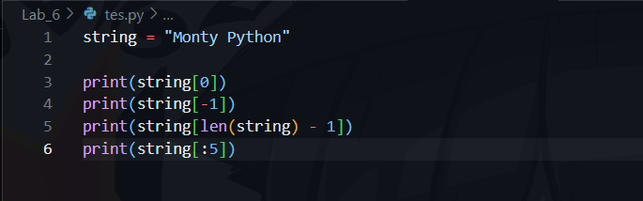
2. A screenshot of a computer

   Description automatically generated